OBJECTIVE: To perform Transient Structural simulation using material whose E=3000Mpa and Poisson Ratio=0.28, Fix one Face and apply force at different faces of hexagon having a time step of 0.2 seconds.
STEPS:
- Open Ansys workbench and create a new project. Drag the “Transient Structural” system into the project workspace. 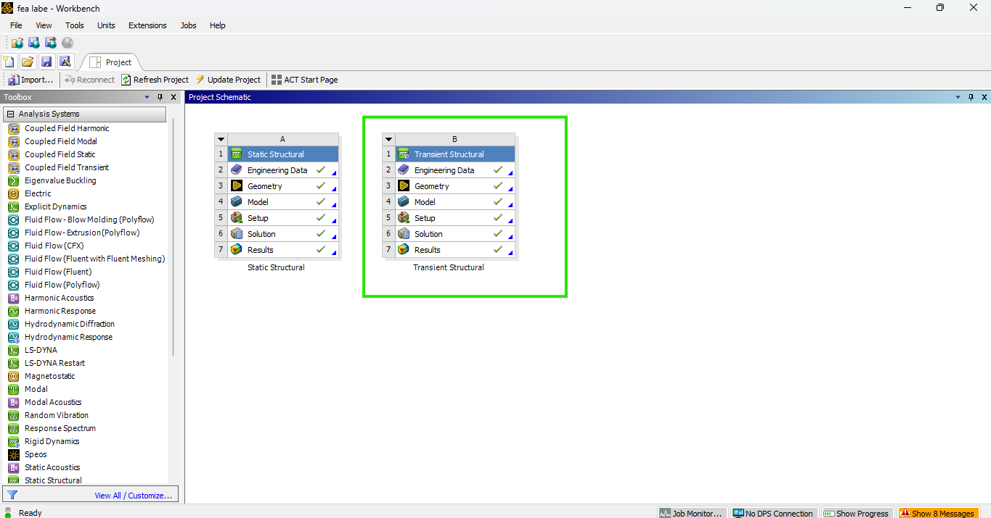
- Go to “Engineering Data” and click on add a new material name it as “abc” and define properties such as Youngs Modulus=3000Mpa and Poisson Ratio=0.28, density=7850kg/metre cube and delete predefined structural steel. 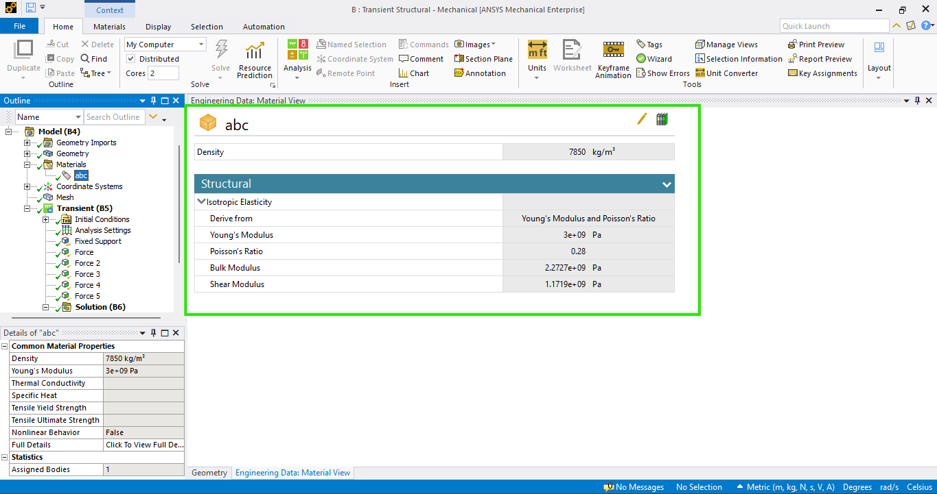

- Double Click on geometry to open the geometry editor Design Modeler. Create a Hexagon in sketching option, extrude it and assign its length=20metre. 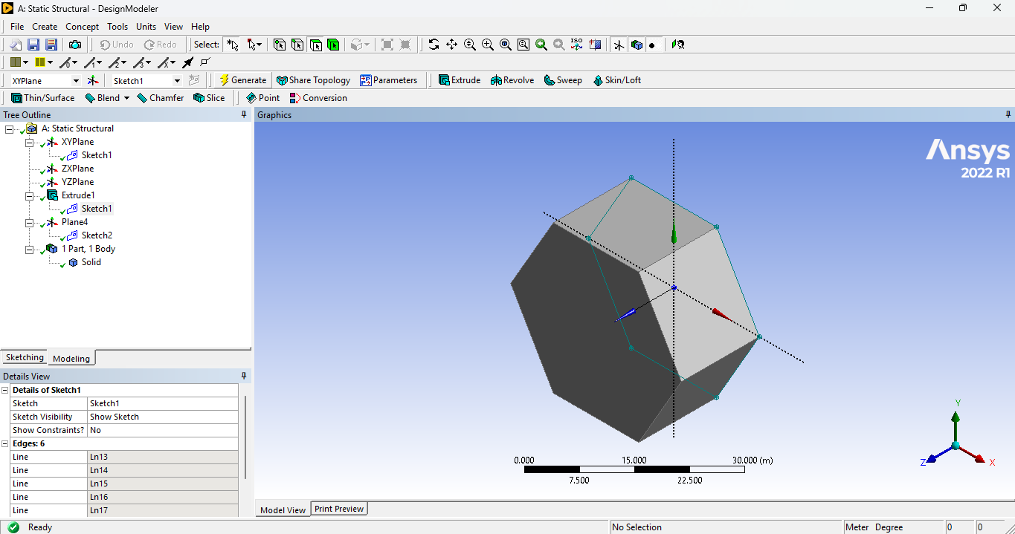
- Double Click on model to enter the Mechanical Interface. Under the “Mesh Section”, Use “Generate Mesh” to create meshing and give sizing and mesh type e.g. (tetrahedron or hexahedron) if necessary. 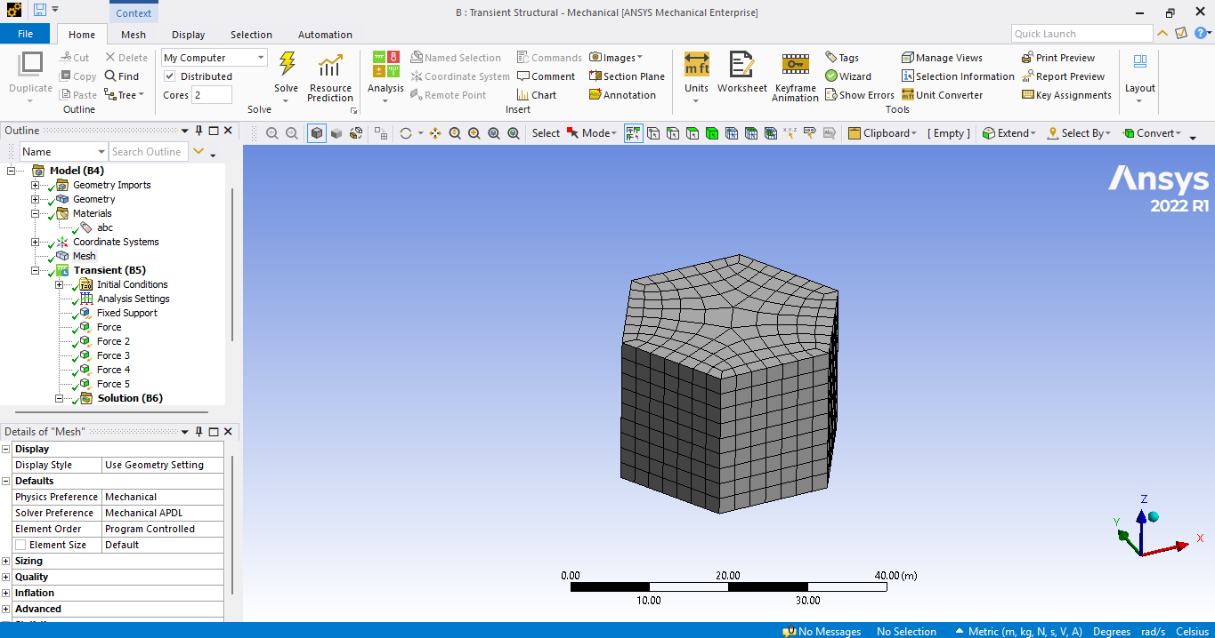

- Apply Boundary Conditions “Fixed support” at the bottom face and apply “Force” at different faces of hexagon each having a time step of 0.2seconds till 1 second this will give you five forces at five different faces to simulate loading conditions. 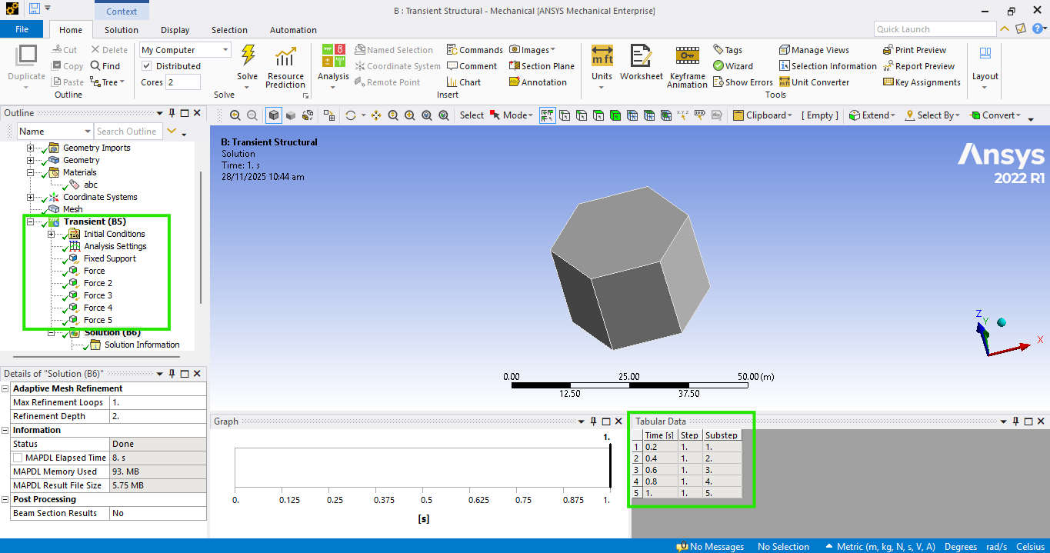

- In the “Solution” select “Total Deformation”, “Equivalent Stress” and “Equivalent Strain” to Calculate it. Now click on “Solve” to run the analysis, The software will compute the “Total Deformation”, “Equivalent Stress” and “Equivalent Strain” under given conditions. 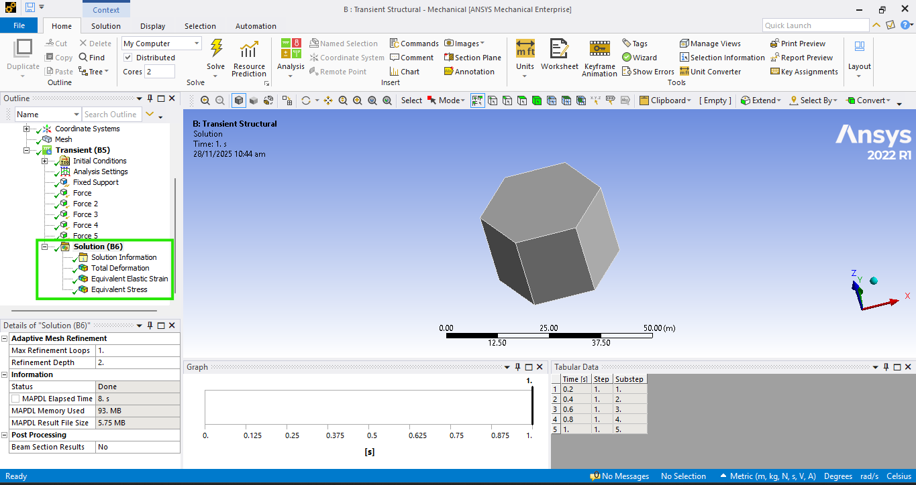
- Now click on “Solve” to run the analysis, The software will compute under given conditions. After Solution is complete view the results in the solution section. 